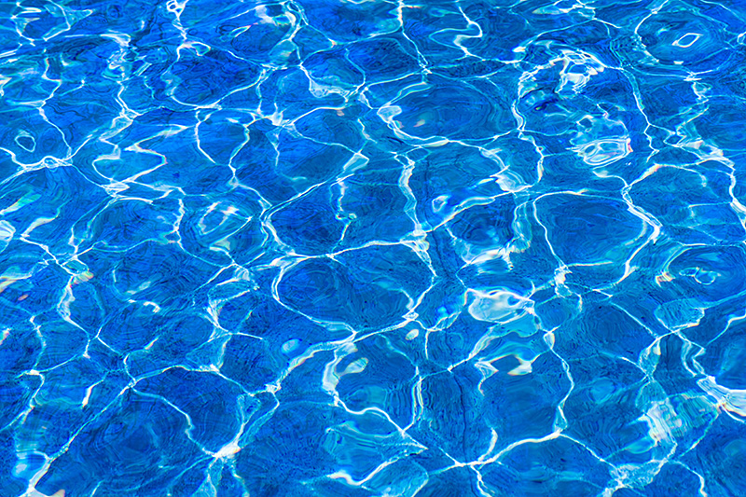

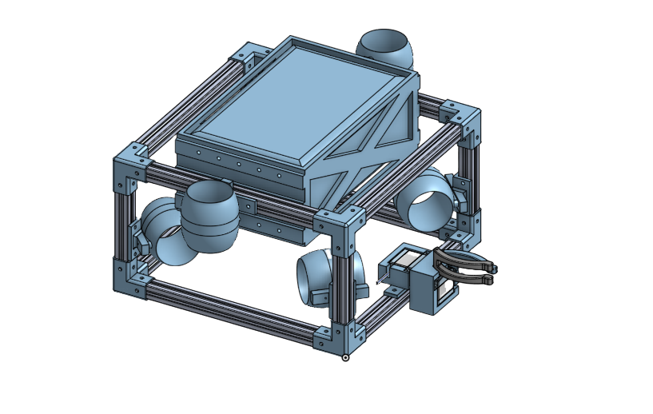

M.A.R.C. (Team 1)
  - Tech Report
  - 
  - Your text here
Uconn Underwater Robotics

Table of COntents
Our Team 3
Abstract
Design Rationale 4
Frame Design
Controls and Electrical Systems 5
Tether Design
Thruster Layout 5
Propulsion 6
Buoyancy 5
Manipulator Claw 5
Safety 4
Thruster Layout 5
Thruster Layout 5
References 4
(Level 3) 6
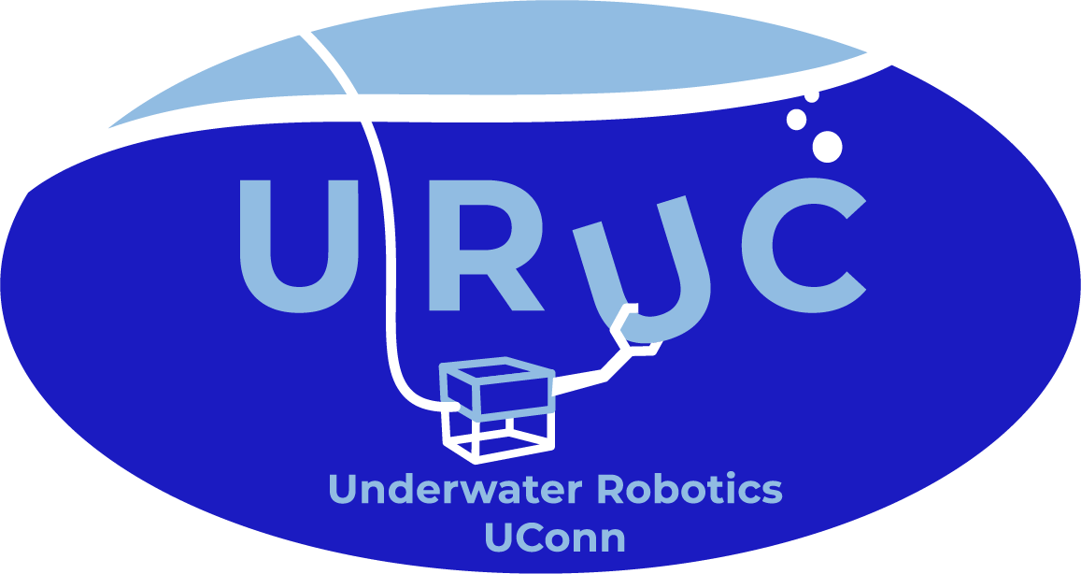

Simon Koepfer - - - - - - - - - - - - - - - - - - - - - - - - - - - - - - - - - - - - President, Mechanical Engineer
Joseph St. Hilaire - - - - - - - - - - - - - - - - - - - - - - - - - - - - - - - - - - Secretary, Mechanical Engineer
Yousif Said - - - - - - - - - - - - - - - - - - - - - - - - - - - - - - - - - - - - - - - - - - - - Programming Team Lead
Jack Taylor - - - - - - - - - - - - - - - - - - - - - - - - - - - - - - - - - - - - - - - - - - - - - - - - - Electrical Engineer
Madelyn Croog - - - - - - - - - - - - - - - - - - - - - - - - - - - - - - - - - - - - - Manipulator Design Engineer
Jibran Ahmed - - - - - - - - - - - - - - - - - - - - - - - - - - - - - - - - - - - - - - Manipulator Design Engineer Michael Valiante - - - - - - - - - - - - - - - - - - - - - - - - - - - - - - - - - - - - - - - - - Frame Design Engineer
Samuel Williams - - - - - - - - - - - - - - - - - - - - - - - - - - - - - - - - - - - - - - - - - Frame Design Engineer
Zander Hernandez - - - - - - - - - - - - - - - - - - - - - - - - - - - - - - - - - - - - - - - - - - - - - - CAD Modeling
Julia Handen - - - - - - - - - - - - - - - - - - - - - - - - - - - - - - - - - - - - - - - Programming and Electronics
Ronit Patel - - - - - - - - - - - - - - - - - - - - - - - - - - - - - - - - - - - - - - - - Programming and Electronics
Dimitri Joseph - - - - - - - - - - - - - - - - - - - - - - - - - - - - - - - - - - - - - Programming and Electronics

Abstract
M.A.R.C. (Making Aquatic Robots Cool) is the first of three teams participating in the UConn Underwater Robotics (URUC) Intra-club competition. Our Remotely Operated Vehicle (ROV) is the product of dedicated teamwork and creativity spanning the entire Fall 2024 semester. Our team is composed of students from various majors, including mechanical and electrical engineering, environmental science, computer science, and more, which has enriched our approach with diverse perspectives. Meeting every Tuesday and Thursday from 6-8 PM, we divided into focused groups to tackle different sections of the robot. Yousif and Jack led the programming and electronics teams, respectively, while Simon and Joey co-led the design team, ensuring a well-coordinated and innovative development process. Together, we worked to create a robust and efficient ROV that we are proud to present in this competition.

Design Rationale

M.A.R.C. is designed with a focus on both ease of use and operational efficiency. Our streamlined frame allows us to channel creativity into other components, such as the manipulator, while ensuring that the ROV remains user-friendly and adaptable. The frame’s aluminum extrusion build provides a durable, professional appearance and enhanced structural integrity, moving away from the PVC framework of past designs. Thrusters are equipped with guards, and the frame has been intentionally crafted with rounded edges, prioritizing safety by eliminating sharp corners. This thoughtful balance of simplicity and robustness makes M.A.R.C. both practical and safe to operate.

Frame Design
This year, we opted for aluminum extrusions to give the frame a more durable and professional appearance. Beyond aesthetics, this choice offers significantly greater structural integrity compared to the PVC pipes used in previous designs. We connected the extrusions using custom-designed parts, 3D-printed in PLA, and additionally printed mounts for attaching the thrusters securely to the frame.

Controls and Electrical Systems

